Nama : Asri Nihal Salsabila

NIM : 18090087

Kelas : 5C

1. URL : <http://localhost/web2/index.php/Latihan1/penjumlahan/5/10>

<http://localhost/web2/index.php/Latihan2/penjumlahan/5/10>

1. Source Code

* application 🡪 controller 🡪 Latihan1.php

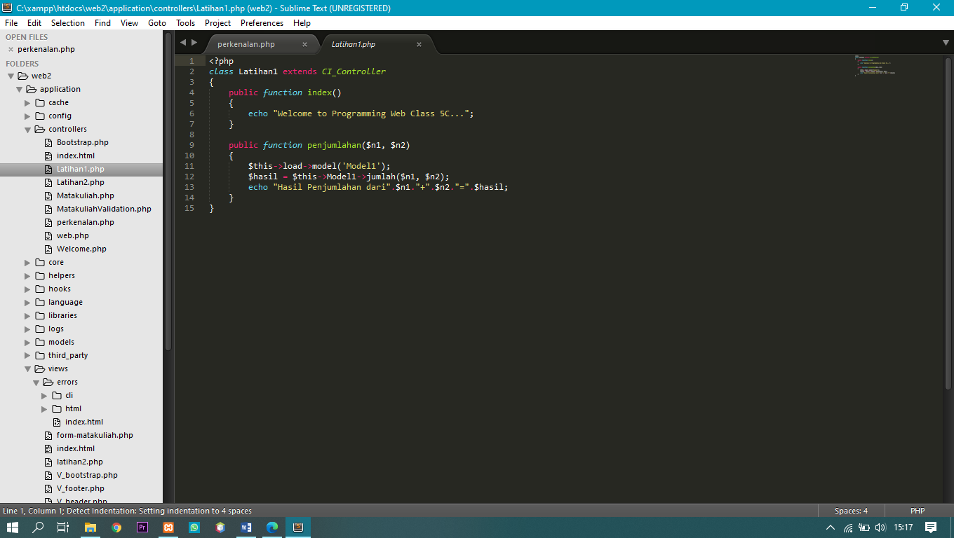

* application 🡪 controller 🡪 Latihan2.php

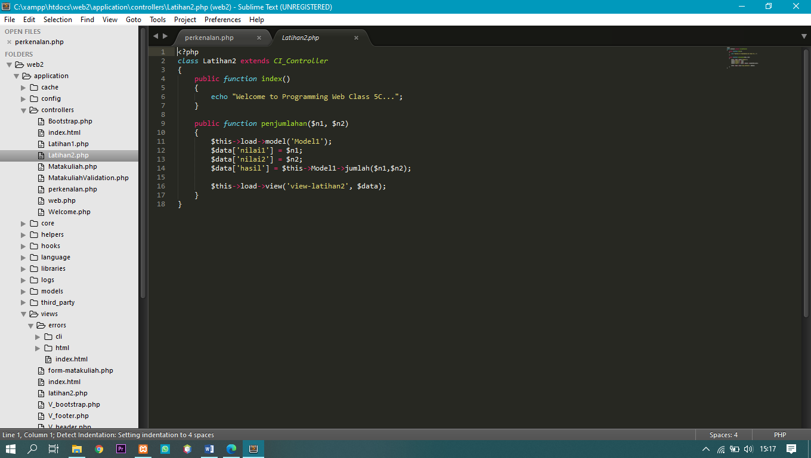

* application 🡪 models 🡪 Model1.php

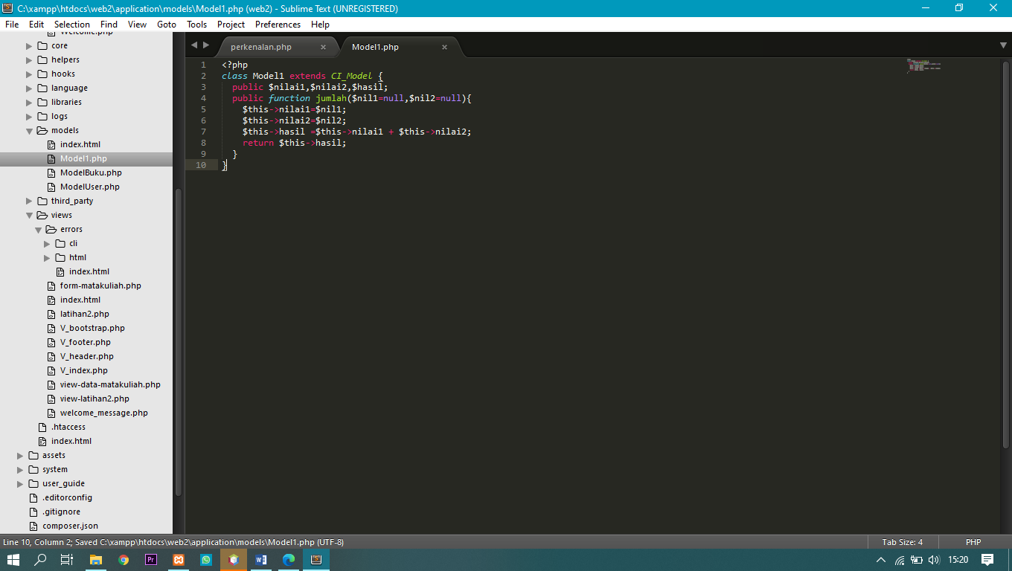

* application 🡪 views 🡪 view-latihan2.php

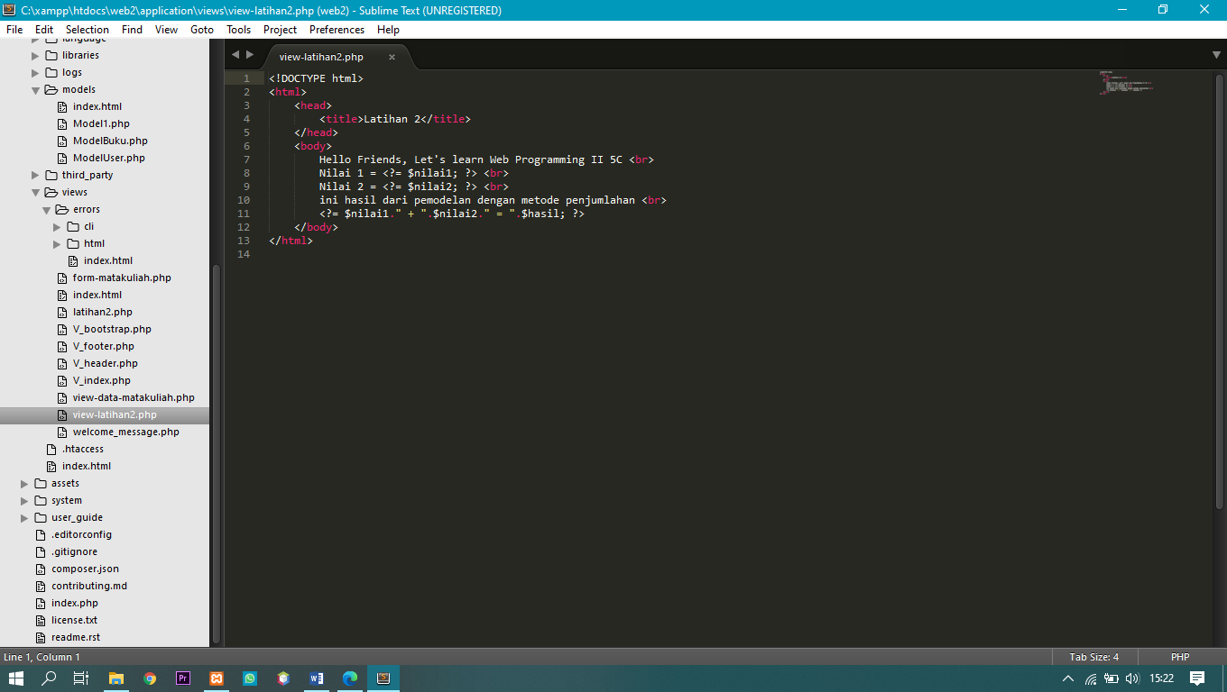

1. Screen Shoot

